Mark Montygierd, B.A
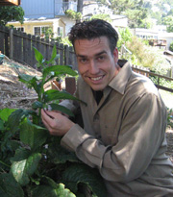
With a B.A. in environmental studies and a passion for rhythm, Mark is currently an instructor at the Riekes Center for Human Enhancement in California. Mark facilitates youth connection to nature while encouraging the interpersonal and intrapersonal growth of participants. Mark recently earned a Permaculture Design Certificate from the Regenerative Design Institute and brings a vision of regenerative relationships to all his work. Using drums for healing since 1988, Mark is a practitioner of the transformative power of music making.

